Table S1. Assignment of fragment ions observed in MS/MS spectrum of (Aβ16 monomer or dimer---Cu).

Parent ion | m/z | Assignment | Parent ion | m/z | Assignment
[M+Cu]²⁺  (m/z 1007.9) | 411.2 | y₃¹⁺ | [M+Cu+2H]⁴⁺  (m/z 504.5) | 457.9 | (y₁₄+Cu+2H)⁴⁺
[M+Cu]²⁺  (m/z 1007.9) | 635.2 | (x₄+Cu-H)¹⁺ | [M+Cu+2H]⁴⁺  (m/z 504.5) | 475.7 | (y₁₅+Cu+2H)⁴⁺
[M+Cu]²⁺  (m/z 1007.9) | 728.3 | a₆¹⁺ | [M+Cu+2H]⁴⁺  (m/z 504.5) | 535.5 | (b₁₃+Cu+H)³⁺
[M+Cu]²⁺  (m/z 1007.9) | 788.8 | (a₁₃+Cu)²⁺ | [M+Cu+2H]⁴⁺  (m/z 504.5) | 567.2 | (y₁₃+Cu+H)³⁺
[M+Cu]²⁺  (m/z 1007.9) | 830.8 | (b₁₄+Cu-81)²⁺ | [M+Cu+2H]⁴⁺  (m/z 504.5) | 572.7 | (y₉+Cu)²⁺
[M+Cu]²⁺  (m/z 1007.9) | 857.3 | (a₁₄+Cu)²⁺ | [M+Cu+2H]⁴⁺  (m/z 504.5) | 581.2 | (b₁₄+Cu+H)³⁺
[M+Cu]²⁺  (m/z 1007.9) | 871.3 | (b₁₄+Cu)²⁺ | [M+Cu+2H]⁴⁺  (m/z 504.5) | 610.3 | (y₁₄+Cu+H)³⁺
[M+Cu]²⁺  (m/z 1007.9) | 914.9 | (y₁₄+Cu)²⁺ | [M+Cu+2H]⁴⁺  (m/z 504.5) | 623.9 | (b₁₅+Cu+H)³⁺
[M+Cu]²⁺  (m/z 1007.9) | 943.8 | (c₁₅+Cu)²⁺ | [M+Cu+2H]⁴⁺  (m/z 504.5) | 630.2 | (y₁₀+Cu)²⁺
[M+Cu]²⁺  (m/z 1007.9) | 950.4 | (y₁₅+Cu)²⁺ | [M+Cu+2H]⁴⁺  (m/z 504.5) | 684.7 | (b₁₁+Cu)²⁺
[M+Cu]²⁺  (m/z 1007.9) | 985.9 | (M+Cu-44)²⁺ | [M+Cu+2H]⁴⁺  (m/z 504.5) | 734.3 | (b₁₂+Cu)²⁺
[M+Cu]²⁺  (m/z 1007.9) | 1144.4 | (y₉+Cu-H)¹⁺ | [M+Cu+2H]⁴⁺  (m/z 504.5) | 802.8 | (b₁₃+Cu)²⁺
[M+Cu]²⁺  (m/z 1007.9) | 1150.5 | a₁₀¹⁺ | (D+Cu+3H)⁵⁺  (m/z 794.3) | 395.1 | (a₆+Cu)²⁺
[M+Cu]²⁺  (m/z 1007.9) | 1378.6 | a₁₂¹⁺ | (D+Cu+3H)⁵⁺  (m/z 794.3) | 409.1 | (b₆+Cu)²⁺
[M+Cu]²⁺  (m/z 1007.9) | 1515.7 | a₁₃¹⁺ | (D+Cu+3H)⁵⁺  (m/z 794.3) | 652.0 | (M+3H)³⁺
[M+Cu]²⁺  (m/z 1007.9) | 1604.6 | (b₁₃+Cu)¹⁺ | (D+Cu+3H)⁵⁺  (m/z 794.3) | 672.3 | (M+Cu+H)³⁺
[M+Cu+H]³⁺  (m/z 672.3) | 395.1 | (a₆+Cu)²⁺ | (D+Cu+3H)⁵⁺  (m/z 794.3) | 739.7 | (M+b₁₄+Cu+H)⁵⁺
[M+Cu+H]³⁺  (m/z 672.3) | 409.1 | (b₆+Cu)²⁺ | (D+Cu+3H)⁵⁺  (m/z 794.3) | 756.9 | (M+y₁₄+Cu+H)⁵⁺
[M+Cu+H]³⁺  (m/z 672.3) | 437.2 | x₃¹⁺ | (D+Cu+3H)⁵⁺  (m/z 794.3) | 768.7 | (M+c₁₅+Cu+H)⁵⁺
[M+Cu+H]³⁺  (m/z 672.3) | 498.2 | (x₃+Cu-H)¹⁺ | (D+Cu+3H)⁵⁺  (m/z 794.3) | 771.1 | (M+y₁₅+Cu+H)⁵⁺
[M+Cu+H]³⁺  (m/z 672.3) | 574.3 | x₄¹⁺ | (D+Cu+3H)⁵⁺  (m/z 794.3) | 833.6 | (M+a₁₂)⁴⁺
[M+Cu+H]³⁺  (m/z 672.3) | 610.3 | (y₁₄+Cu+H)³⁺ | (D+Cu+3H)⁵⁺  (m/z 794.3) | 848.9 | (M+a₁₂+Cu)⁴⁺
[M+Cu+H]³⁺  (m/z 672.3) | 629.6 | (c₁₅+Cu+H)³⁺ | (D+Cu+3H)⁵⁺  (m/z 794.3) | 867.9 | (M+a₁₃)⁴⁺
[M+Cu+H]³⁺  (m/z 672.3) | 633.9 | (y₁₅+Cu+H)³⁺ | (D+Cu+3H)⁵⁺  (m/z 794.3) | 871.4 | b₇¹⁺
[M+Cu+H]³⁺  (m/z 672.3) | 635.2 | (x₄+Cu-H)¹⁺ | (D+Cu+3H)⁵⁺  (m/z 794.3) | 883.1 | (M+a₁₃+Cu)⁴⁺
[M+Cu+H]³⁺  (m/z 672.3) | 657.6 | (M+Cu-44)³⁺ | (D+Cu+3H)⁵⁺  (m/z 794.3) | 890.1 | (M+b₁₃+Cu)⁴⁺
[M+Cu+H]³⁺  (m/z 672.3) | 689.8 | a₁₂²⁺ | (D+Cu+3H)⁵⁺  (m/z 794.3) | 904.1 | (M+b₁₄+Cu-81)⁴⁺
[M+Cu+H]³⁺  (m/z 672.3) | 720.3 | (a₁₂+Cu)²⁺ | (D+Cu+3H)⁵⁺  (m/z 794.3) | 913.7 | (M+y₁₃+Cu)⁴⁺
[M+Cu+H]³⁺  (m/z 672.3) | 728.3 | a₆¹⁺ | (D+Cu+3H)⁵⁺  (m/z 794.3) | 917.4 | (M+a₁₄+Cu)⁴⁺
[M+Cu+H]³⁺  (m/z 672.3) | 758.3 | a₁₃²⁺ | (D+Cu+3H)⁵⁺  (m/z 794.3) | 924.4 | (M+b₁₄+Cu)⁴⁺
[M+Cu+H]³⁺  (m/z 672.3) | 788.8 | (a₁₃+Cu)²⁺ | (D+Cu+3H)⁵⁺  (m/z 794.3) | 945.9 | (M+y₁₄+Cu)⁴⁺
[M+Cu+H]³⁺  (m/z 672.3) | 802.8 | (b₁₃+Cu)²⁺ | (D+Cu+3H)⁵⁺  (m/z 794.3) | 977.5 | (M+2H)²⁺
[M+Cu+H]³⁺  (m/z 672.3) | 830.8 | (b₁₄+Cu-81)²⁺ | (D+Cu+3H)⁵⁺  (m/z 794.3) | 1012.8 | (M+y₉)³⁺
[M+Cu+H]³⁺  (m/z 672.3) | 857.3 | (a₁₄+Cu)²⁺ | (D+Cu+3H)⁵⁺  (m/z 794.3) | 1051.2 | (M+y₁₀)³⁺
[M+Cu+H]³⁺  (m/z 672.3) | 871.3 | (b₁₄+Cu)²⁺ | (D+Cu+H)³⁺  (m/z 1323.2) | 871.4 | b₇¹⁺
[M+Cu+H]³⁺  (m/z 672.3) | 943.8 | (c₁₅+Cu)²⁺ | (D+Cu+H)³⁺  (m/z 1323.2) | 977.5 | (M+2H)²⁺
[M+Cu+H]³⁺  (m/z 672.3) | 1150.5 | a₁₀¹⁺ | (D+Cu+H)³⁺  (m/z 1323.2) | 1007.9 | (M+Cu)²⁺
[M+Cu+H]³⁺  (m/z 672.3) | 1198.6 | y₁₀¹⁺ | (D+Cu+H)³⁺  (m/z 1323.2) | 1260.9 | (M+y₁₄+Cu)³⁺
[M+Cu+2H]⁴⁺  (m/z 504.5) | 324.2 | (y₅+H)²⁺ | (D+Cu+H)³⁺  (m/z 1323.2) | 1548.7 | (M+y₉+Cu)²⁺
[M+Cu+2H]⁴⁺  (m/z 504.5) | 378.7 | (b₆+H)²⁺ | (D+Cu+H)³⁺  (m/z 1323.2) | 1734.8 | (M+a₁₃)²⁺
[M+Cu+2H]⁴⁺  (m/z 504.5) | 436.2 | (b₇+H)²⁺ | (D+Cu+H)³⁺  (m/z 1323.2)

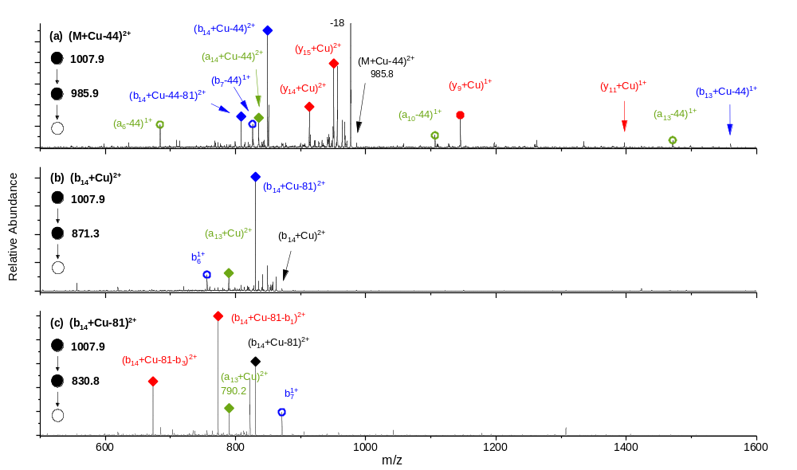
Figure S1. MS/MS/MS spectra of (a) [M+Cu-44]²⁺, (b) [b₁₄+Cu]²⁺, and [b₁₄+Cu-81]²⁺ parent ion. The charge states are distinguished by different shapes (1+ = circle, 2+ = diamond). The a, b, and y fragment ions are indicated by green, blue, and red colors, respectively. The filled shapes indicate the existence of Cu ions in fragment ions.

