Supporting Information

Unusual applications of Kendrick plots: recalibration and tolerance

Thierry N. J. Fouquet,* Orlando Cabarcos
Surgical Analytical & Materials Science (SAMS), Bausch & Lomb, 1400 N Goodman St, Rochester NY 14609, USA.*E-mail: thierry.fouquet@bausch.com, thierry.fouquet83@gmail.com

Content | Page
1) List of abbreviations | S2
2) Evaluation of scan-to-scan variability used as tolerance for blank subtraction: example for Orbitrap data | S3
Figure S1: UPLC-MS(TIC) of (A) a blank and (B) polyTHF; (C) BPC from (B); (D) Kendrick plot from the scans 2040 - 2065 of (A) (red dots) and (B) (black dots) using R=72.0575, Z=1 and x=144. Insets: magnified plot around a background peak (yellow) and diffused background signal (purple); (E, F) Blank-subtracted UPCLC-MS(TIC) from (B) using a tolerance of +/- 0.2 mDa and +/- 0.4 mDa. | S4

1) List of abbreviations

(UP)LC-MS: (Ultra-high Performance) Liquid Chromatography Mass Spectrometry

LC/GC-MS(/MS): Liquid Chromatography or Gas Chromatography Mass Spectrometry and Tandem Mass Spectrometry

m/z: mass-to-charge ratio

ESI: Electrospray Ionization

HR MS: High-Resolution Mass Spectrum or Mass Spectrometry

polyTHF: poly(tetrahydrofuran)

R: exact mass of a repeating moiety (e.g. for polyTHF, R=72.0575)

IUPAC: International Union of Pure and Applied Chemistry

IM QTOF: Ion Mobility Quadrupole Time-Of-Flight (mass spectrometer)

TIC: Total Ion Chromatogram

BPC: Base Peak Chromatogram

MS^{n}: Multistage Mass Spectrometry (e.g. MS³ = MS/MS/MS)

SWATH: Sequential Window Acquisition of all Theoretical Fragment Ion, one type of data independent acquisition

MS^{E}: Another type of data independent acquisition

2) Evaluation of scan-to-scan variability used as tolerance for blank subtraction: example for Orbitrap data

Short experimental: UPLC-MS data were recorded using an Orbitrap Exploris 120 mass spectrometer coupled to a Vanquish chromatography system (Thermo, resolving power at m/z 200 ~ 120,000). Data files were converted from Thermo’s proprietary format .RAW to .mzML using MSConvert 3.0.23060-c109104 (filters: peak-picking “vendor, MS1” and threshold “absolute intensity”=200 cts). Kendrick analyses were computed using “kendo2” v 2.1.2, a standalone program written by the author with Visual Studio 2022 v. 17.3.0 available online for download.

The same procedure presented in the main article for the blank subtraction of UPLC-MS of polyTHF using a QTOF mass spectrometer (resolving power ~25k) has been conducted using an Orbitrap mass spectrometer (resolving power ~120k), with a Figure S1 similar to Figure 4 briefly discussed below.
Figure S1A and S1B show the TIC from the UPLC-MS (Orbitrap) analysis of a blank and the polyTHF sample, with discrete background peaks and diffuse background noise, the former not being removed in the BPC (Figure S1C).
Figure S1D shows a Kendrick plot generated from the scans 2040-2065 from the TICs of the polyTHF sample (black bubbles) and blank (red bubbles) corresponding to one discrete background peak. Zooming in around the largest bubbles (yellow shape, most intense ion in the mass spectrum), a dispersion of ~0.4 mDa for the m/z values of the blank and of the sample is readily visualized along the y-axis. Zooming in around a minor signal, a very slightly greater dispersion of m/z values scan-to-scan is instantly evaluated at ~0.8 mDa by the program (same scales used in Figure 4 in the main article for a quick comparison). Blank-subtracted TICs for the polyTHF sample are generated using the so-evaluated +/- 0.2 mDa (Figure S1E) and +/-0.4 mDa (Figure S1F) as tolerances. The TICs are very similar, free of both the discrete background peaks and the diffuse background noise. The baseline of the chromatogram is near 0 throughout the run, a minor cyclic polyTHF series is revealed (green triangles), and the longest polyTHF chains eluting in the last minutes are clearly visible (blue dots).

The graphical evaluation of the tolerance for the blank subtraction works equally well for the QTOF data file (resolving power at ~25k) and the Orbitrap data file (resolving power ~120k) with no need for any input from the analyst: the dispersion of points in the Kendrick plot reveals the accuracy, and its evaluation by the program provides a rationally chosen tolerance for the blank subtraction, well-suited for the mass spectrometer resolving power. The same procedure will work for other high-resolution mass spectrometers (e.g. TOF or FT-ICR).

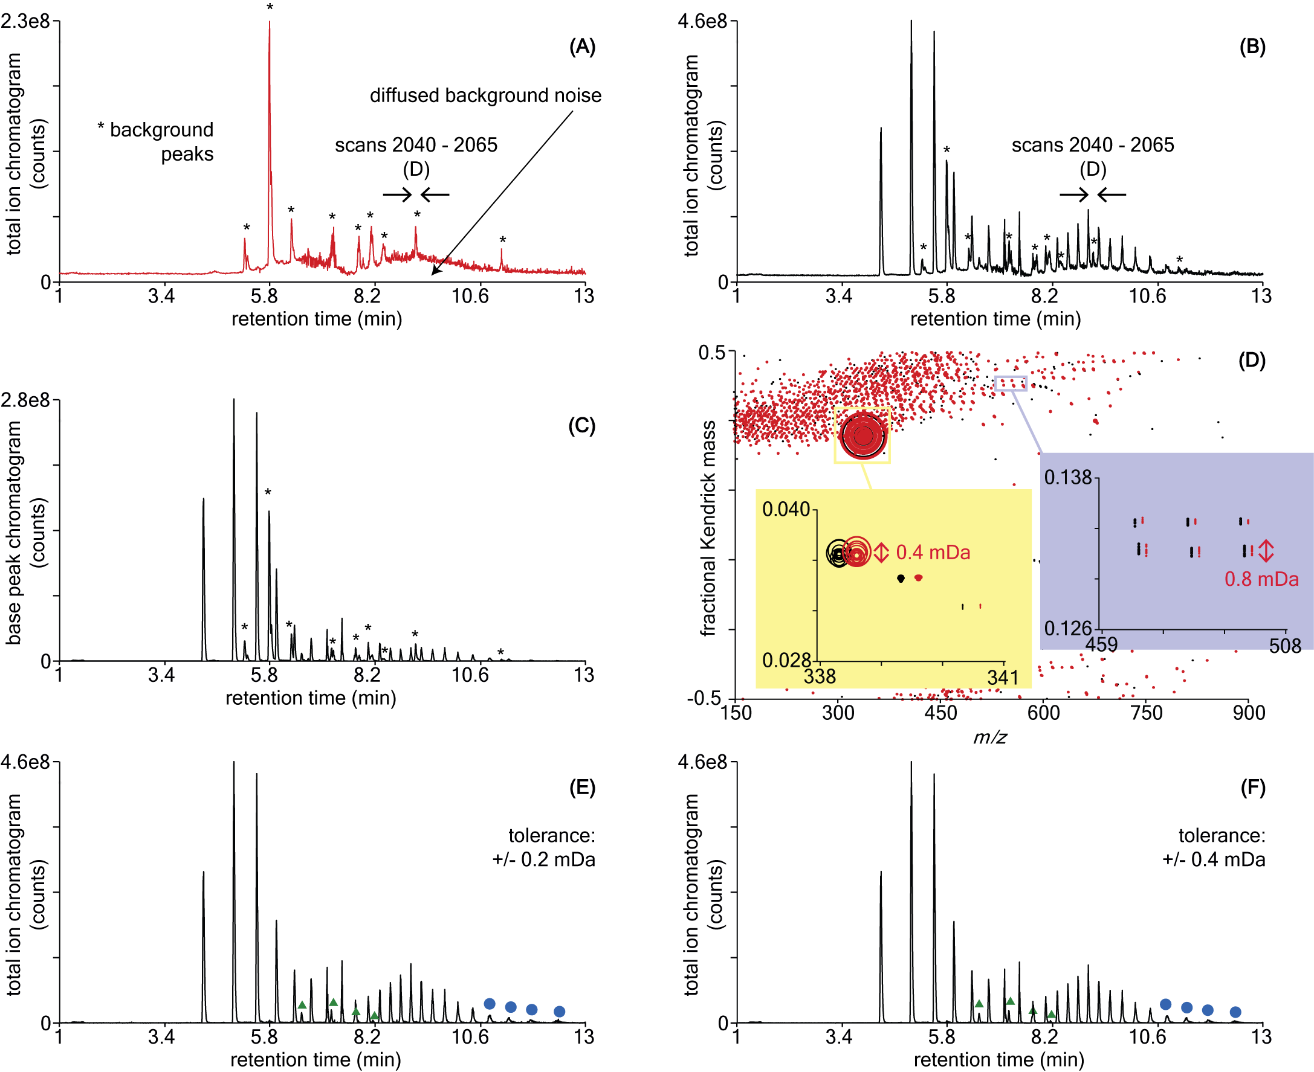

Figure S1: UPLC-MS(TIC) of (A) a blank and (B) polyTHF; (C) BPC from (B); (D) Kendrick plot from the scans 2040 - 2065 of (A) (red dots) and (B) (black dots) using R=72.0575, Z=1 and x=144. Insets: magnified plot around a background peak (yellow) and diffused background signal (purple); (E, F) Blank-subtracted UPCLC-MS(TIC) from (B) using a tolerance of +/- 0.2 mDa and +/- 0.4 mDa.

